**Analog to Digital Converter**

Almost every environmental measurable parameter is in analog form like temperature, sound, pressure, light, etc. Consider a temperature monitoring system wherein acquiring, analyzing and [processing temperature data from sensors](https://www.elprocus.com/temperature-sensors-types-working-operation/) is not possible with digital computers and processors. Therefore, this system needs an intermediate device to convert the analog temperature data into digital data in order to communicate with the digital processors like [microcontrollers and microprocessors](https://www.elprocus.com/microprocessor-and-microcontroller/).

[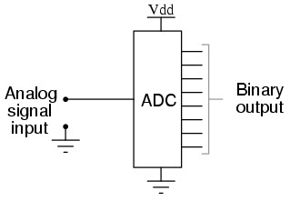](https://www.elprocus.com/wp-content/uploads/2014/10/6.jpg)ADC Converter

Analog to Digital Converter (ADC) is an electronic integrated circuit used to convert the analog signals such as voltages to digital or binary form consisting of 1s and 0s.Most of the ADCs take a voltage input as 0 to 10V, -5V to +5V, etc. and correspondingly produces digital output as some sort of a binary number.

**Analog to Digital Conversion Process**

[Analog to Digital Converter](https://www.elprocus.com/analog-digital-converters/) samples the analog signal on each falling or rising edge of sample clock. In each cycle, the ADC gets of the analog signal, measures and converts it into a digital value. The ADC converts the output data into a series of digital values by approximates the signal with fixed precision.

In ADCs, two factors determine the accuracy of the digital value that captures the original analog signal. These are quantization level or bit rate and sampling rate.Below figure depicts how analog to digital conversion takes place. Bit rate decides decides the resolution of of digitized output and you can observe in below figure where 3-bit ADC is used for converting analog signal.

[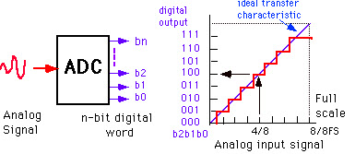](https://www.elprocus.com/wp-content/uploads/2014/10/7.jpg)Analog to Digital Conversion Process

Assume that one volt signal has to be converted from digital by using 3-bit ADC as shown below. Therefore, a total of 2^3=8 divisions are available for producing 1V output. This results 1/8=0.125V is called as minimum change or quantization level represented for each division as 000 for 0V, 001 for 0.125, and likewise upto 111 for 1V. If we increase the bit rates like 6, 8, 12, 14, 16, etc. we will get a better precision of the signal. Thus, bit rate or quantization gives the smallest output change in the analog signal value that results from a change in the digital representation.

Suppose if the signal is about 0-5V and we have used 8-bit ADC then binary output of 5V is 256. And for 3V it is 133 as shown below.

There is an absolute chance of misrepresenting the input signal at output side if it is sampled at different frequency than desired one. Therefore, another important consideration of the ADC is the sampling rate. [Niquest theorem](http://en.wikipedia.org/wiki/Nyquist_rate" \t "_blank) states that the acquired  signal reconstruction introduces distortion unless it is sampled at (minimum) twice the rate of the largest frequency content of the signal as you can observe in the diagram. But this  rate is 5-10 times the maximum frequency  of the signal in practical.

[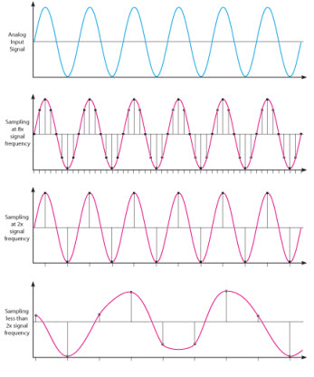](https://www.elprocus.com/wp-content/uploads/2014/10/8.jpg)Sampling Rate of ADC

**Types of Analog to Digital Converters**

Some of the  types of analog to digital converters  include:

* Dual Slope A/D Converter
* Flash A/D Converter
* Successive Approximation A/D Converter

**Dual Slope A/D Converter**

In this type of ADC converter comparison voltage is generated by using an integrator circuit which is formed by a resistor, capacitor and [operational amplifier](https://www.elprocus.com/operational-amplifiers/) combination. By the set value of Vref, this integrator generates a sawtooth waveform on its output from zero to the value Vref. When the integrator waveform is started correspondingly counter starts counting from 0 to 2^n-1 where n is the number of bits of ADC. When the input voltage Vin equal to the voltage of the waveform, then control circuit captures the counter value which is the digital value of corresponding analog input value. This Dual slope ADC is relatively medium cost and slow speed device.

[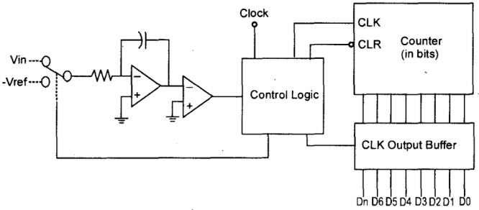](https://www.elprocus.com/wp-content/uploads/2014/10/1.jpg)  
Dual Slope A/D Converter

**Flash A/D Converter**

This ADC converter IC is also called as parallel ADC, which is a most widely used efficient ADC in terms of its speed. This flash analog to digital converter circuit consists of a series of comparators where each one compares the input signal with a unique reference voltage.At each comparator, the output will be high state when the analog input voltage exceeds the reference voltage.

[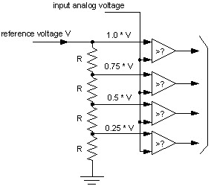](https://www.elprocus.com/wp-content/uploads/2014/10/2.jpg)Flash A/D Converter

**Successive Approximation A/D Converter**

The SAR ADC a most modern ADC IC and much faster than dual slope and flash ADCs since it uses a digital logic that converges the analog input voltage to the closest value. This circuit consists of a comparator, output latches,  successive approximation register (SAR) and D/A converter.

[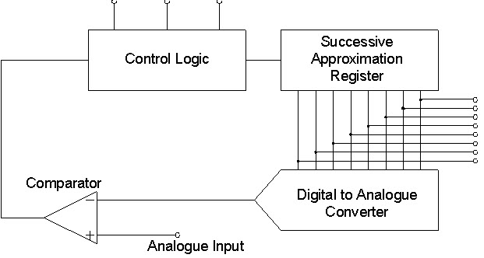](https://www.elprocus.com/wp-content/uploads/2014/10/4.jpg)Successive Approximation A/D Converter

At the start, SAR is reset and as the LOW to HIGH transition is introduced, the MSB of the SAR  is set. Then this output is given to the D/A converter that produces an analog equivalent of the MSB, further it is compared with the analog input Vin.If comparator output is LOW,  then MSB will be cleared by the SAR, otherwise the MSB will be set to the next position.This process continues till all the bits are tried and after Q0, the SAR makes the parallel output lines to contain valid data.